**Goal:**

In this sprint, we want to finish any backlogged tasks from previous sprints. Then, the app will be thoroughly tested and revised if necessary. Code and git will be cleaned up. All branches will be merged, and if not, deleted. If there is extra time, user stories below will be implemented.

**User Story Task Planning:**

As a user, I want to see who is in my group

* List group members in the group page - 3 hours

As a user, I want to be able to let my housemate know anonymously that they are being too loud so that I don’t have to confront them about it.

* Add a function to check user notify attribute in the table every 10 seconds if user needs to be notified and notify them - 5 hours

As a user, I want to see how loud my housemates have been so that I know if they are improving or not

* Track user history in the database - 5 hours
* Display individual group member history in the group page - 5 hours

**Roles:**

Abdullah Al-Omari: Developer

John Leckrone: Developer

Akihiro Mizusawa: Developer

Jiying Qi: Product Owner, Developer

Vincent Thai: Scrum Master, Developer

**Initial Task Assignment:**

Abdullah Al-Omari:

John Leckrone:

Akihiro Mizusawa:

Jiying Qi:

Vincent Thai:

**Initial burnup chart:**

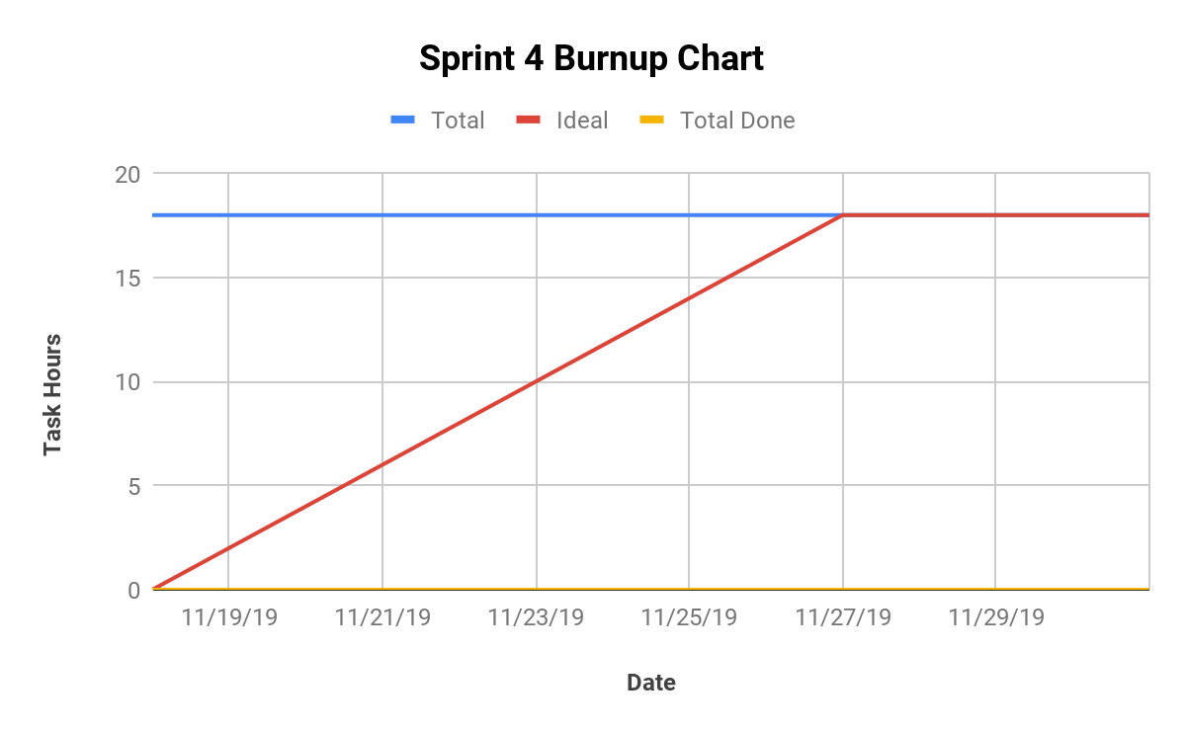

**Scrum times:**

Monday 6:00 - 6:30 PM Baskin 302

Wednesday 6:00 - 6:30 PM Various Locations

Friday 5:00 - 5:30 PM with Scott Davis Baskin 302